Addition or removal of an item on NCR
Scenario: FC needs to either add an item to their menu or remove an item that they no longer want.

- Access to NCR Homepage

"Could you please provide me with the items you wish to add or remove?" [wait for a response] Once you receive it, repeat the items back to the customer to ensure you have all the necessary information.

- Click the house icon in the top right corner of the screen.
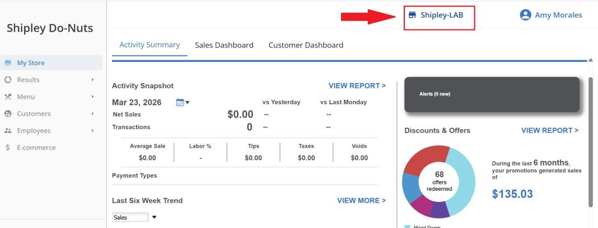
- Enter the store number provided by the FC (e.g., FC7992) into the search bar and click on it to access the client’s profile.
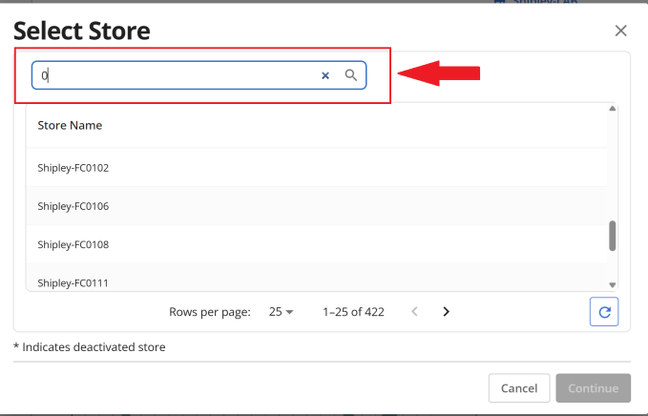

- On the left side of your screen, go to Menu Settings and select MENU.
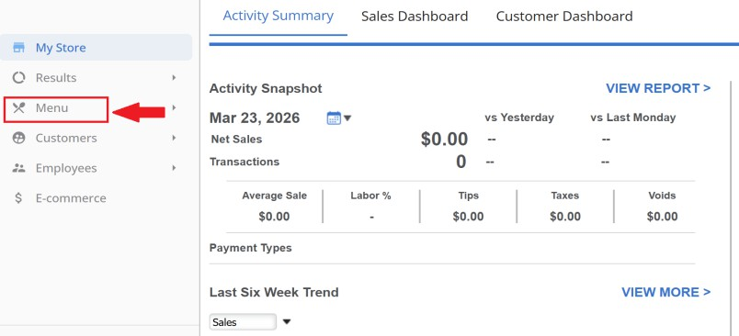
- Select the first option CATEGORIES AND ITEMS.
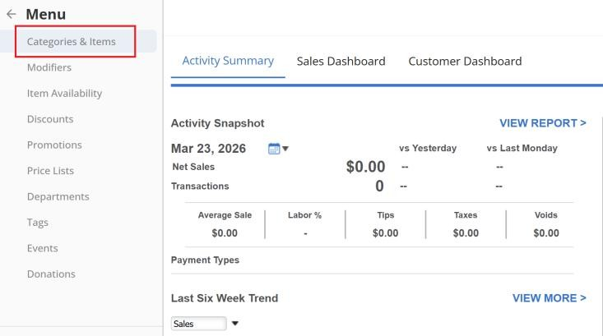
- A list of menu items will appear on the left side of the page. Scroll to the bottom of the list and select

EDIT MULTIPLE ITEMS.
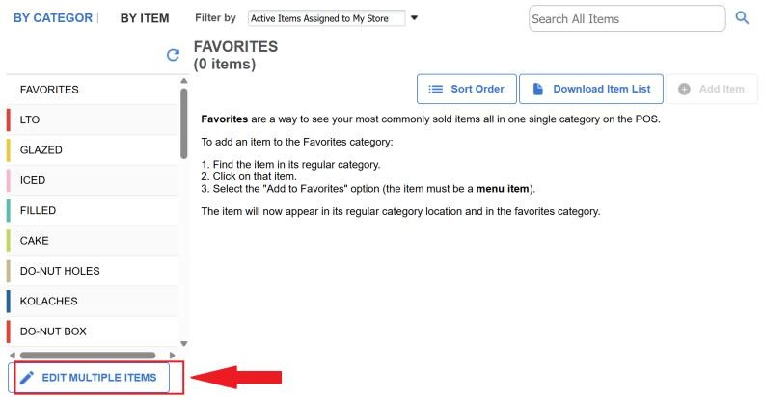

- A pop-up will appear where you can search for any item by CATEGORY (e.g., glazed items) or by

NAME/DESCRIPTION.
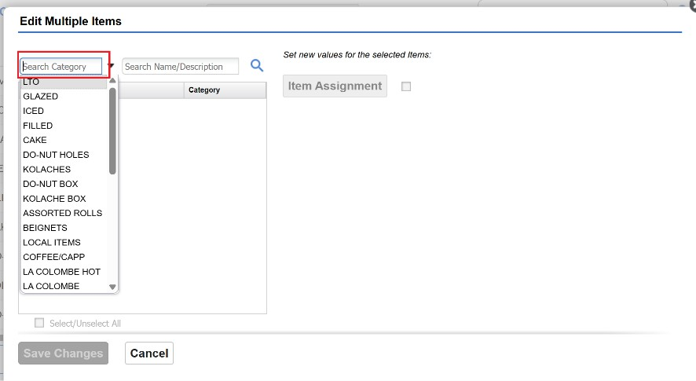
- Search for the item you want using the CATEGORY or NAME/DESCRIPTION fields.
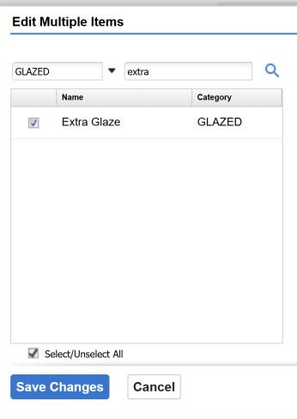

TO ADD AN ITEM

  - Select the item you want to add, then click ITEM ASSIGMENT.
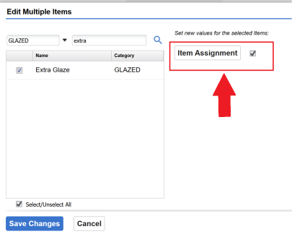
  - A new pop-up will appear. Please check the box of the item.
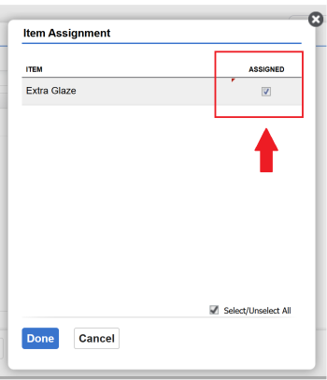
  - Select DONE to finish.
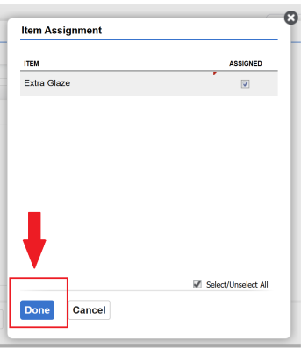

  - Click on SAVE CHANGES.
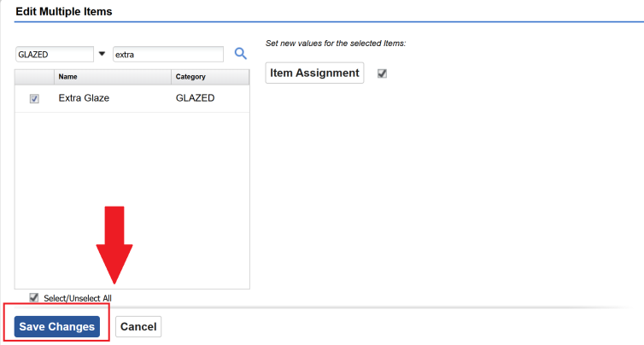
  - Confirm your selection by clicking OK.
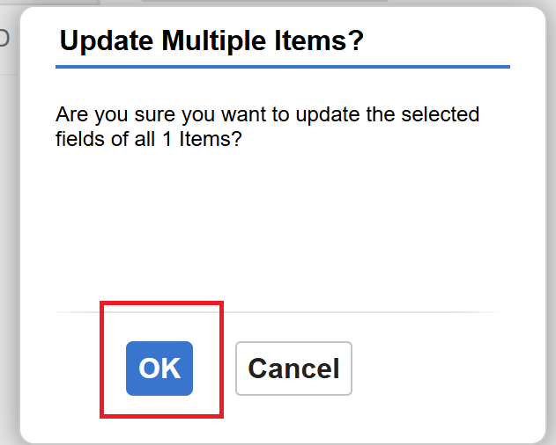

  - You will be redirected to the main page. To confirm that the item was added, select CATEGORY
to view it.
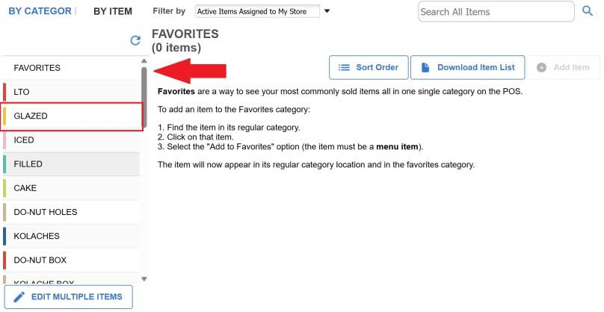

  - You can also confirm that the item has been removed from the main page.
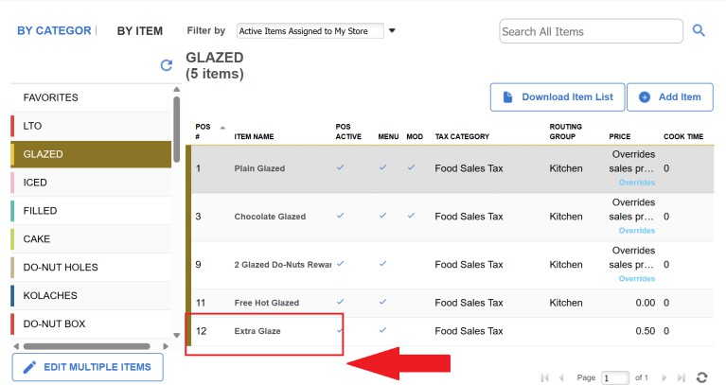

REMOVE AN ITEM

- Select the item you want to remove, then click ITEM ASSIGMENT.

- A new pop-up will appear. Please uncheck the box of the item.
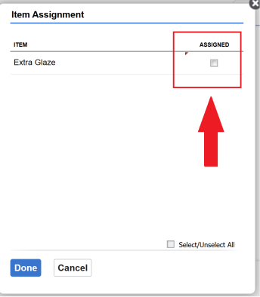
- Select DONE to finish.
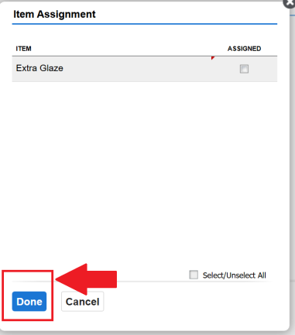

- Click on SAVE CHANGES.

- Confirm your selection by clicking OK.


- You will be redirected to the main page. To confirm that the item was added, select CATEGORY to view it.


- You can also confirm that the item has been removed on the main page.
